**Raspberry Pi Lab**

The purpose of this lab is to get exposure to the Raspberry Pi microcontroller. The Raspberry Pi is a very affordable device that can do a lot of things. The device is very powerful compare to its size and cost. The device can host servers, install a complete operating system with all its applications. Simply, Raspberry Pi is microcontroller that can be customized to whatever project in mind.   
  
There are six sections in this lab. In the first section we will be installing the system on microSD card. Second, we will write a simple python program. Third, we will write a simple C program. Forth, we are going to build a LED circuit with a button in python and C. in the fifth part, we are going to build a connection between two devices over LAN network using Raspberry pi. Lastly, we will create an application that will combine the knowledge we got from the previous parts.

**Part 1: Raspberry Pi Setup**   
In this part we are going to install the operating system on our SD card. Also, we are going to setup the environment to enable us to build our projects.  
  
- In this step, Operating Systems is installed and the WIFI is connected. Python 2.7 is installed

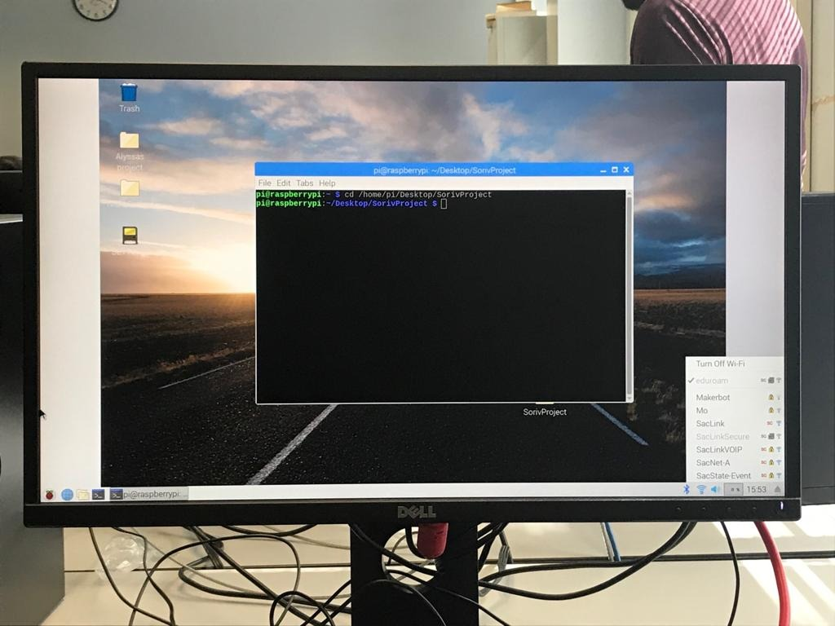  
  
  
**Part 2: Python on Raspberry Pi**In this lab we are going to build a Python program and compile it using the Raspberry terminal. The program will be a simple Hello world. However, we are going to learn how to create a file and write then compile. All that through the terminal

* Using Nano edit, we wrote this simple program to output Hello World into testfile.text.

#!/usr/bin/python

file = open(“testfile.txt”,”w”)

file.write(“Hello World”)

file.close()

* Navigate to the right directory, then Python testfile.py to run.  
    
  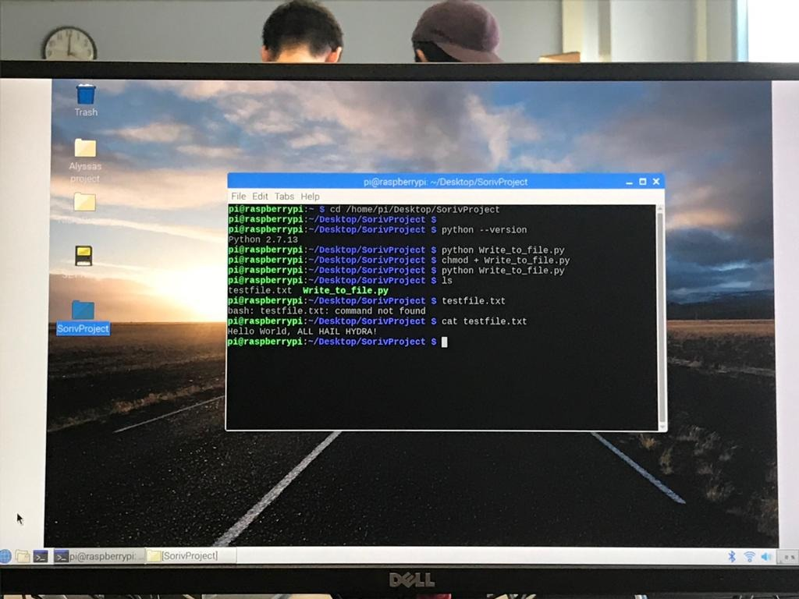

**Part 3: Writing a C/C++ Program for Raspberry Pi**In this section, we are going to repeat what we did for part 2 but this time we are going to write and compile the program using C language.

* Again, using nano editor, we wrote hello.c to start writing C program

#include <stdio.h>

int main(){

printf(“Hello World\n”);

return 0;

}

* We compile the program using gcc -o hello hello.c and run it using ./hello   
    
  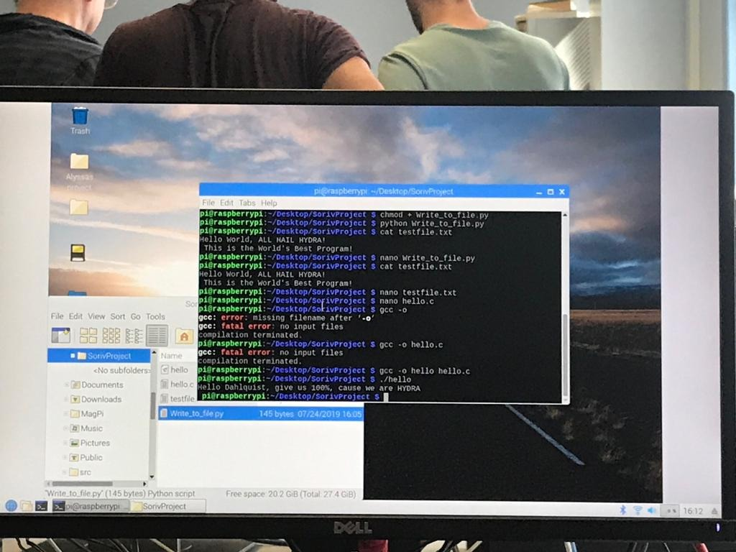

**Part 4: Use GPIO for Raspberry Pi**

For this part we are going to use a simple LED circuit and push button circuit. Using a breadboard, LED light, resistor, button, and we are going to program it using:  
  
 1. Python || 2. C  
  
First we had to build the circuit. We had to locate what pin we are going to use so we can reference it when we program it. Pin 13 is going to be used to configure the GPIO for Raspberry Pi. For the circuit, we connected the Raspberry Pi to the breadboard using pin 13, then a wire from the LED to ground and another to from LED and Power to button.

# External module imports

import RPi.GPIO as GPIO

import time

# Pin Definitons:

ledPin = 17 # Broadcom pin 17 (PI pin 11)

buttonPin = 27 # Broadcom pin 17 (PI pin 13)

# Pin Setup:

GPIO.setmode(GPIO.BCM)

GPIO.setup(ledPin, GPIO.OUT)

GPIO.setup(buttonPin, GPIO.IN)

# Initial state for LED:

GPIO.output(ledPin, GPIO.LOW)

print("Simple Python GPIO Start! Press CTRL+C to exit")

try:

while 1:

if GPIO.input(buttonPin):

GPIO.output(ledPin, GPIO.HIGH)

else:

GPIO.output(ledPin, GPIO.LOW)

except KeyboardInterrupt: # If CTRL+C is pressed, exit and clean

GPIO.cleanup() # cleanup all GPIO

* Python Programming

- To build the file, we navigate to the right folder in the terminal. Then using nano editor and wrote the following code.

* python gpiotest.py to run the program. We notice that when we press the button that is connected to pin 13. The LED is on.  
    
  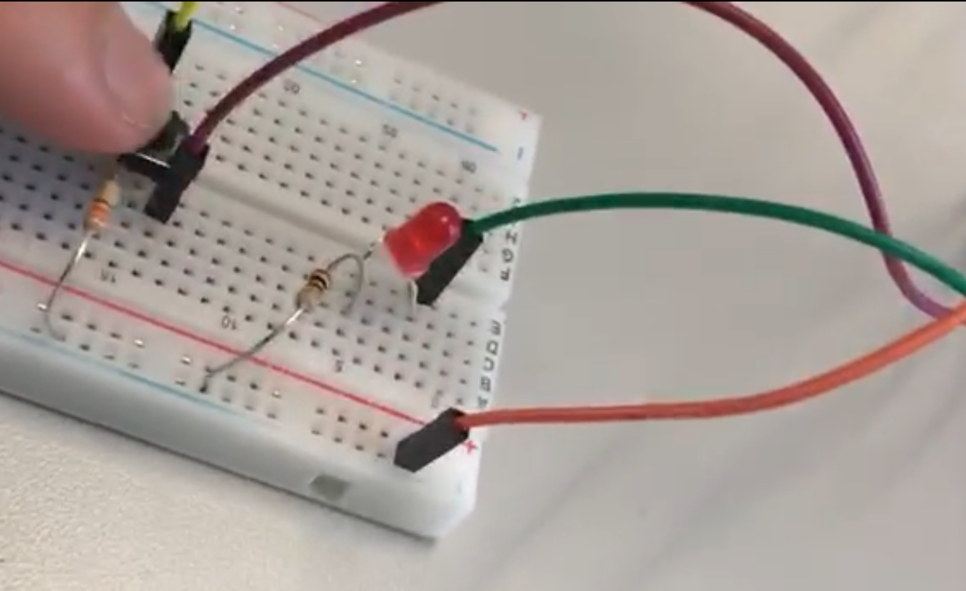

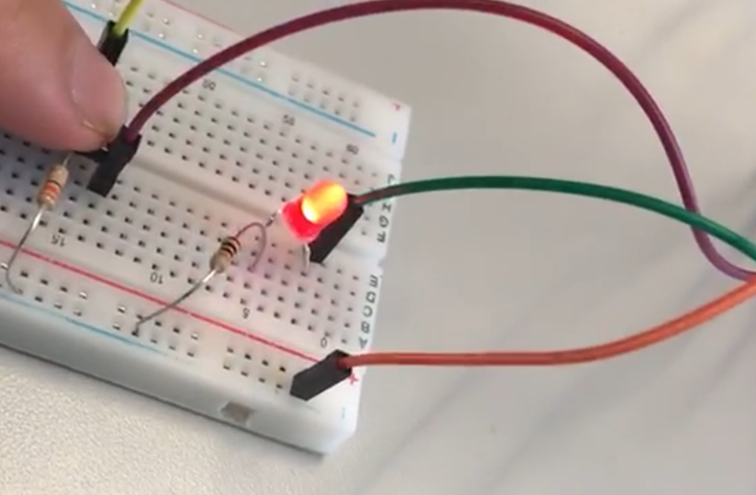

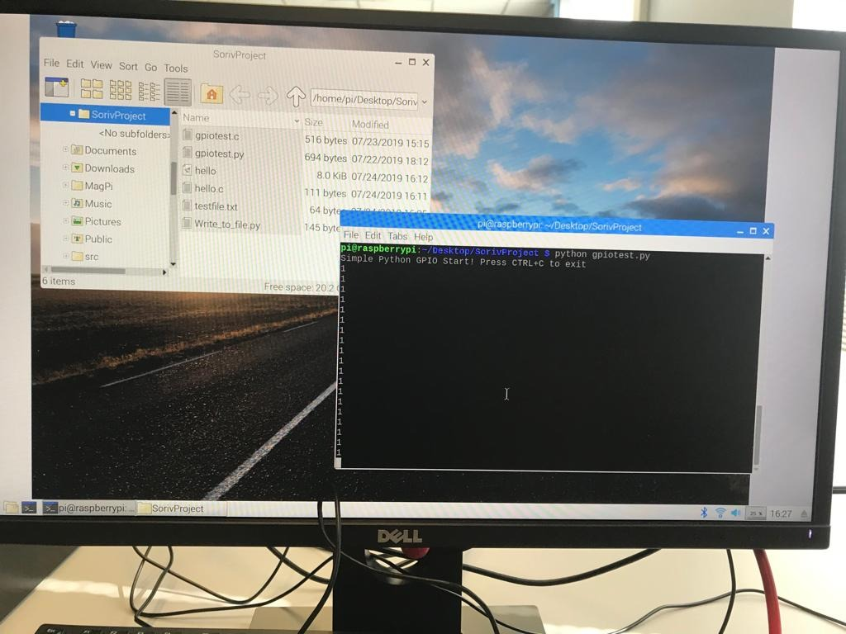

* C++. Same process. Except the file will be .c and the following code.

#include <stdio.h> // Used for printf() statements

#include <wiringPi.h> // Include WiringPi library!

int main(void)

{

// Setup stuff:

wiringPiSetupGpio(); // Initialize wiringPi -- using Broadcom pin numbers

pinMode(ledPin, OUTPUT); // Set regular LED as output

pinMode(butontPin, INPUT); // Set button as INPUT

printf("C GPIO program running! Press CTRL+C to quit.\n");

while(1){if (digitalRead(buttonPin)) digitalWrite(ledPin, HIGH);

else {digitalWrite(ledPin, LOW);}}

return

}

* gcc -o gpiotest gpiotest.c -l wiringPi to compile and ./gpiotest to run.  
    
  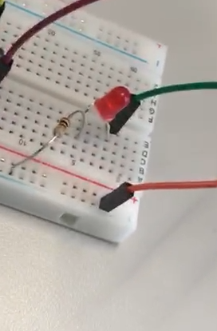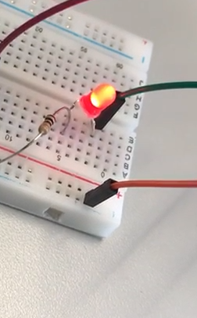  
    
  0 is off and 1 is on.

**Part 5: TCP/UDP Communication**

For this part we are going to biuld a program that allows the Raspberry Pi to comminicate

with another divice on the same LAN. Raspberry Pi using network protocols and

gpio pins to control devices over the internet or send data remotely.

- On the Raspberry Pi create the following python file. This will be the host or the server. This application has to be open before we try to connect. Simply. This will allow a port to be open, in our case is port 8080, this port will allow the packets in.

#!/usr/bin/env python

import socket

TCP_IP = '0.0.0.0'

TCP_PORT = 8080

BUFFER_SIZE = 20 # Normally 1024, but we want fast response

s = socket.socket(socket.AF_INET, socket.SOCK_STREAM)

s.bind((TCP_IP, TCP_PORT))

s.listen(1)

conn, addr = s.accept()

print 'Connection address:', addr

while 1:

data = conn.recv(BUFFER_SIZE)

if not data: break

print "received data:", data

conn.send(data) # echo

conn.close()

-This is the server. We need to run it using python serverPi.py before attempting to connect.

-We need to know our local IP address, we can look that up either by typing hostname -I in the termnial or simply by hover over the newtork icon.

- On the over computer we have to create a python file and write the following code.  
  
Once we run this program and the server is open we should see the messgae “Hello world” appears on both the server and the client. That means that both devices are connected.

#!/usr/bin/env python

import socket

TCP_IP = '0.0.0.0’' # We USED the right IP

TCP_PORT = 8080

BUFFER_SIZE = 1024

MESSAGE = "Hello, World!"

s = socket.socket(socket.AF_INET, socket.SOCK_STREAM)

s.connect((TCP_IP, TCP_PORT))

s.send(MESSAGE)

data = s.recv(BUFFER_SIZE)

s.close()

print "received data:", data

* To run the program on the client side we had to match the right Python version. We were expericne some difficulties with syntex errors. After matching we used python IDLE to write and compile.  
    
  Server..  
  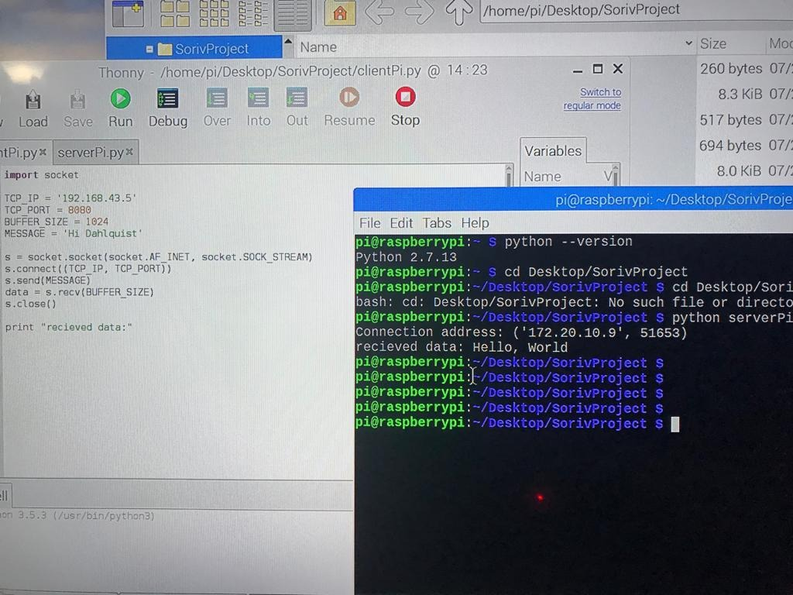

Client...

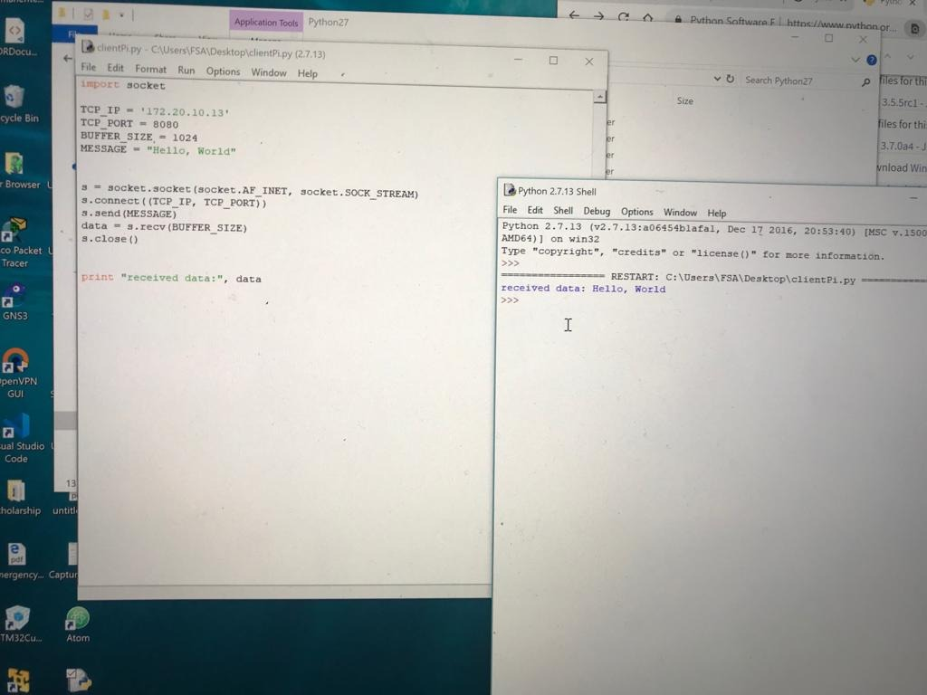

The connection was seccessful. We were able to see the message ‘Hello World!’ print out on both the Raspberry Pi and our client computer.

**Part 6: Project**

For our project we build a program using Raspberry Pi to control 4 LED lights. The program allows you to select from 3 different choices. Each option is going to light up the LEDs in different patterens. The program was build using Python and it uses GPIO.

PINS used are 18, 23, 24, and 25. And ground.

* Code

led = LED(18)

led.on()

time.sleep(1)

led = LED(25)

led.on()

time.sleep(1)

led.off()

led = LED(24)

led.on()

time.sleep(1)

led.off()

led = LED(18)

led.on()

time.sleep(1)

led.off()

if select == "3":

for i in range(0, 3):

led = LED(25)

led.on()

time.sleep(1)

led.off()

led = LED(24)

led.on()

time.sleep(1)

led.off()

led = LED(23)

led.on()

time.sleep(1)

led.off()

led = LED(18)

led.on()

time.sleep(1)

led.off()

from gpiozero import LED

import time

print ("Option 1")

print ("Option 2")

print ("Option 3")

select = input("select an option: ")

print(select)

if select == "1":

for i in range(0, 3):

led = LED(18)

led.on()

time.sleep(1)

led.off()

led = LED(23)

led.on()

time.sleep(1)

led.off()

led = LED(24)

led.on()

time.sleep(1)

led.off()

led = LED(25)

led.on()

time.sleep(1)

led.off()

if select == "2":

for i in range(0, 3):

led = LED(24)

led.on()

time.sleep(1)

led.off()

* Program running.

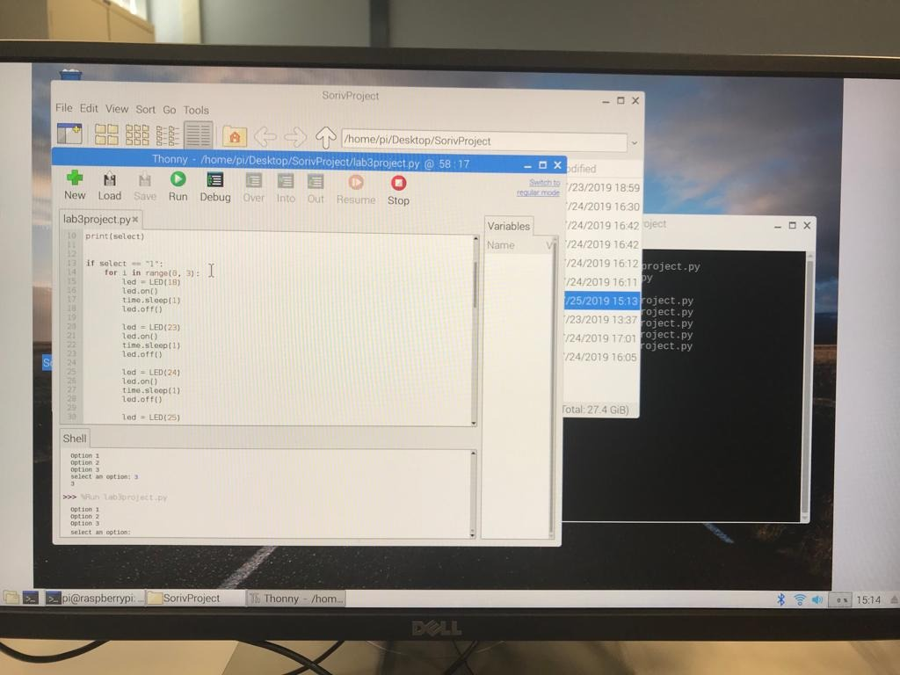

* Circuit used

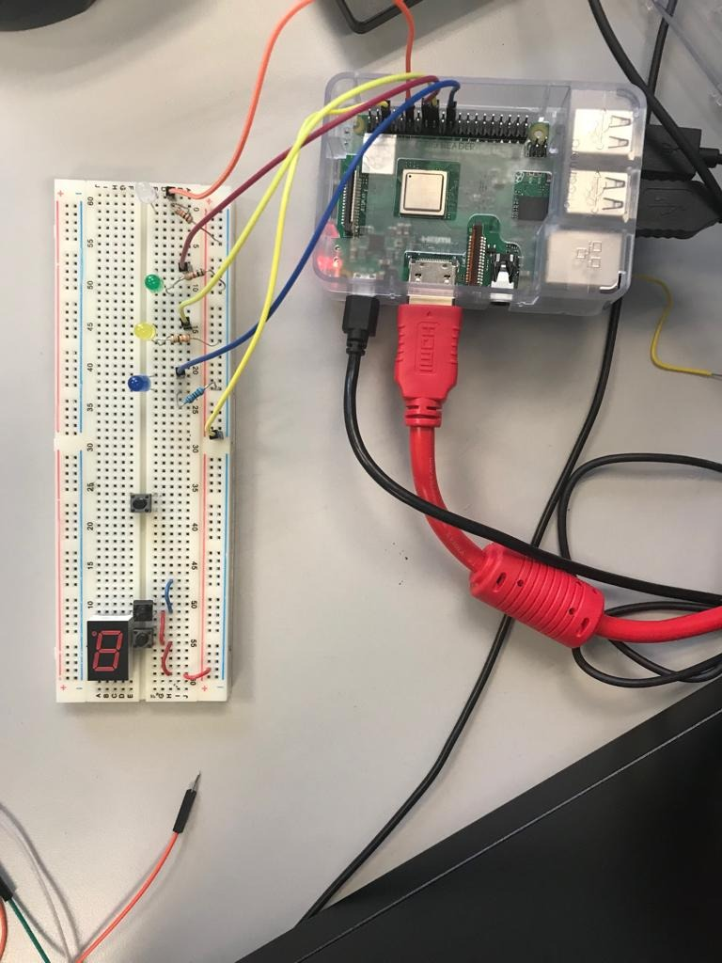

At the end of this lab, I think I got the basics of using Raspberry Pi. The product is amazing and it has a lot off potetnial to build many project. One in particular is to host my own server instead of using online server. This one could be really helpful to my as I need and use such service. It will not be easy but because of the basics we got from this lab I think I can do it.